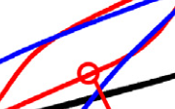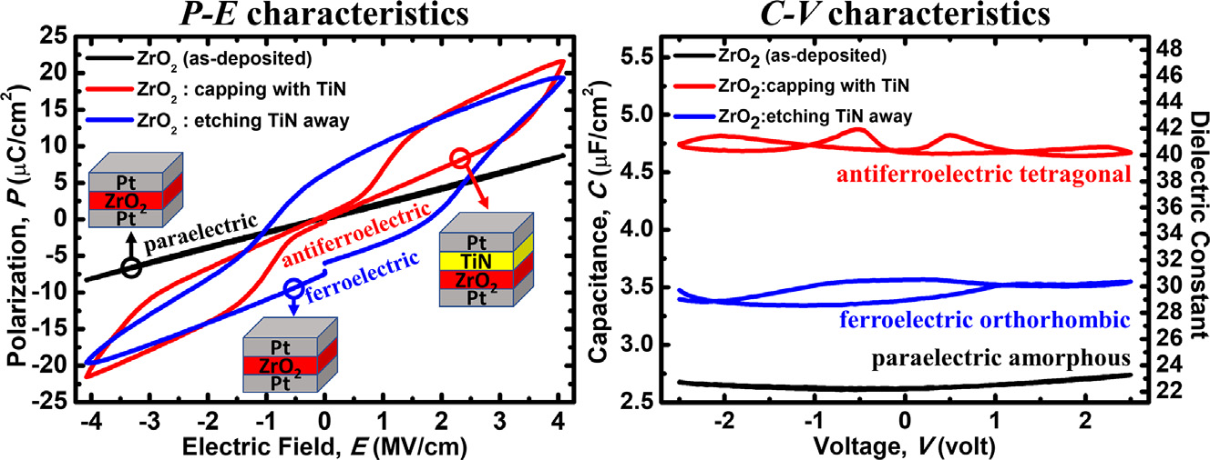

[Materials and Design 195 (2020) 109020](https://doi.org/10.1016/j.matdes.2020.109020)

|  |  |  |  |  |
| --- | --- | --- | --- | --- |
|  | |  | | --- | | Contents lists available at [ScienceDirect](http://www.sciencedirect.com/science/journal/) |  |  | | --- | | Materials and Design |   journal homepage: www.elsevier.com/locate/matdes |  |
| Paraelectric/antiferroelectric/ferroelectric phase transformation in As-deposited ZrO2 thin films by the TiN capping engineering | |  |

Chun-Yuan Wanga, Chin-I Wanga, Sheng-Han Yia, Teng-Jan Changa, Chun-Yi Choua, Yu-Tung Yina, Makoto Shiojirib, Miin-Jang Chena,⁎

a Department of Materials Science and Engineering, National Taiwan University, Taipei, Taiwan   
b Kyoto Institute of Technology, Kyoto, Japan

|  |  |  |
| --- | --- | --- |
| H I G H L I G H T S | G R A P H I C A L | A B S T R A C T |

• The TiN capping layer induces ZrO2

|  |  |
| --- | --- |
| transformation from paraelectric amor-phous phase to antiferroelectric tetrago- |  |

nal phase.

• Etching TiN away results in relaxation of   
ZrO2 from antiferroelectric tetragonal   
phase to ferroelectric orthorhombic   
phase.

|  |  |  |  |  |  |
| --- | --- | --- | --- | --- | --- |
| • The | TiN | layer | can | modulate | the |
| antiferroelectric | | | and | ferroelectric | |

phases in ZrO2 thin films without high-  
temperature annealing.

|  |  |  |
| --- | --- | --- |
| a r t i c l e | i n f o | a b s t r a c t |
| Article history:  Received 20 April 2020  Received in revised form 30 July 2020 Accepted 31 July 2020  Available online 03 August 2020 | | Based on the engineering of the TiN capping layer, the tailoring of the crystalline phases and the paraelectric(PE)/ antiferroelectric(AFE)/ferroelectric(FE) properties of nanoscale ZrO2 thin films are demonstrated without any post-annealing treatment. The capping by the TiN layer leads to the conversion of ZrO2 from the PE to the AFE electrical characteristics, while the removal of the TiN capping layer results in the AFE-to-FE phase transforma-tion of ZrO2. The nano-beam electron diffraction, high-resolution transmission electron microscopy and X-ray |
| Keywords:  Antiferroelectricity and ferroelectricity Atomic layer deposition  Phase transformation  Zirconium oxide and titanium nitride Capping layer effect | | diffraction characterizations identify the presence of the AFE tetragonal and FE orthorhombic phases in ZrO2, and the observations reveal the emergence of the out-of-plane compressive and in-plane tensile strains in the ZrO2 layers by the TiN capping layer as well. The results demonstrate the significant impact of the TiN capping layer effect on the crystalline phases and dielectric properties of nanoscale thin films at a low temperature, which may play an important role in the FE/AFE applications which need a low thermal budget.  © 2020 The Authors. Published by Elsevier Ltd. This is an open access article under the CC BY-NC-ND license ([http://](http://creativecommons.org/licenses/by-nc-nd/4.0/) |

[creativecommons.org/licenses/by-nc-nd/4.0/](http://creativecommons.org/licenses/by-nc-nd/4.0/)).

|  |  |
| --- | --- |
| 1. Introduction | characteristics, providing two stable polarization states which form |

the basis for the memory devices, including ferroelectric random access

In recent years, the switchable polarization in ferroelectric (FE) and antiferroelectric (AFE) materials under the applied electric field have re-ceived widespread attention. The most distinguishing feature of FE ma-terials is a hysteresis loop in the polarization-electric field (P-E)

⁎ Corresponding author.

E-mail address: [mjchen@ntu.edu.tw](mailto:mjchen@ntu.edu.tw) (M.-J. Chen).

<https://doi.org/10.1016/j.matdes.2020.109020>

memory, ferroelectric tunnel junctions and ferroelectric field-effect transistors [1–5]. In contrast to FE materials, a double hysteresis loop without remanent polarization is present in the P-E curve of AFE mate-rials, ascribed to the field-induced transition from a non-polar or anti-polar phase to a polar phase [6–8]. Thus, AFE materials can find a variety of applications such as pyroelectric energy harvesting and electrocaloric cooling [9–13]. In addition, the FE and AFE dielectrics have been

0264-1275/© 2020 The Authors. Published by Elsevier Ltd. This is an open access article under the CC BY-NC-ND license (<http://creativecommons.org/licenses/by-nc-nd/4.0/>).

C.-Y. Wang, C.-I. Wang, S.-H. Yi, et al.

proposed in the gate stack of nanoscale transistors in order to

|  |  |  |  |  |  |  |
| --- | --- | --- | --- | --- | --- | --- |
| achieve | the | sub-60 | mV/decade | subthreshold | swing | operation |

due to their negative capacitance effect during the polarization switching [14–16]. Hence, the FE and AFE materials exhibit high poten-tials in broad applications for energy harvest/storage/conversion, micro-electromechanical systems (MEMS) and ultra-low-power nanoelectronics [17–26].

Pb(Zr, Ti)O3 (PZT) and PbZrO3 (PZ) with the perovskite structures are the well-known FE and AFE materials [2,23]. However, the high con-tent of lead gives rise to the limitation in practical applications due to environmental issues. Recently, the FE and AFE characteristics of Hf/ Zr-based oxide thin films have been demonstrated by the careful control of film structures and processing conditions [27–30]. In order to reach significant FE and AFE features of Hf/Zr-based oxide thin films, the post-deposition or post-metallization annealing at temperatures ≧400 °C is needed for the formation of the FE orthorhombic (o-) phase and the AFE tetragonal (t-) phase [28,30–33]. However, the high-temperature annealing processes result in undesirable dopant diffusion and uncontrollable chemical reactions at interfaces, which are not fa-vorable to the process integration as the device scaling is down to sub-10 nm semiconductor technology nodes [32,34]. Hence, the capa-bility of crystallization for nanoscale thin films at low temperatures below 400 °C, as well as the precise tailoring of their crystalline phases, is highly advantageous for state-of-the-art nanoscale devices in numer-ous applications.

In this study, we report the transformation of the paraelectric(PE)/ AFE/FE phases in the ZrO2 thin films by engineering the nanoscale TiN capping layer without any high-temperature post-annealing. The AFE characteristics of ZrO2 were induced by the TiN capping layer, while etching the TiN capping layer away leads to the transition of ZrO2 from the AFE to the FE phase. The PE/AFE/FE phase transformation and strains in ZrO2 layers were characterized by the X-ray diffraction (XRD), high-resolution transmission electron microscopy (HRTEM) and the nano-beam electron diffraction (NBED) characterizations. The finding demonstrates that the TiN capping layer engineering is an effec-tive and feasible method to modulate the FE/AFE properties of nano-scale thin films at a low thermal budget.

Materials and Design 195 (2020) 109020

Fig. 1(a)-(c), are referred to as the Z0, ZT and ZTe samples, respectively. It is seen that the Z0 sample has the Pt/ZrO2/Pt MIM structure. A ~ 10 nm TiN capping layer (electrode) was deposited upon the ZrO2 layer to form the Pt/TiN/ZrO2/Pt MIM structure in the ZT sample. For the ZTe sample, this TiN capping layer was etched away by the mixture solution consisting of ammonium hydroxide (NH4OH), hydrogen peroxide (H2O2) and water (H2O). Notice that this solution has high etching se-lectivity between the oxide and TiN [35]. For each sample, the top elec-trode Pt with a side length of 70 μm was defined by the optical lithography and lift-off process. Notice that the Z0, ZT and ZTe samples were not treated with any post-annealing processes. Two sets of MIM structures were fabricated, in which the ZrO2 layer was deposited with a thickness of 7.5 nm at 250 °C and 6 nm at 200 °C, respectively, in order to elucidate the PE/AFE/FE phase transition in ZrO2 with differ-ent thicknesses prepared at different temperatures.

The HRTEM characterization of the MIM structures was performed by a FEI Tecnai G2 system operated at 200 kV, and the samples for the HRTEM observation were prepared by the focused ion beam (Helios NanoLab 400 s, FEI) system. The Fast Fourier Transform (FFT) of the HRTEM images were performed by the Digital Micrograph (Gatan, USA) software. The NBED patterns were obtained on the focal plane of the objective lens. The thin film thickness was measured by the spectroscopic ellipsometry (SE, M-2000, J.A. Woollam) and HRTEM. The crystalline phase of ZrO2 layer was detected by the out-of-plane (2θ/ω) X-ray diffraction (XRD, TTRAX III, Rigaku) with Cu-kα radiation (λ = 0.15418 nm). The electrical characterization was performed by a Keithley 4200-SCS semiconductor characterization system. An excita-tion of 2 kHz bipolar triangular voltage waveform was used to measure the polarization and current density versus the electric field (P-E and J-E) curves, and a 100 kHz 30 mV ac voltage was employed to probe the small-signal capacitance-voltage (C-V) characteristics.

3. Results and discussion

In the first set of experiments, the ZrO2 layer in the Z0, ZT, and ZTe MIM structures was deposited at 250 °C. The cross-sectional TEM im-ages of the MIM structures of ZT and ZTe samples are displayed in

|  |  |
| --- | --- |
| 2. Experimental | Fig. 2 (a) and (b). The ZrO2 layer thicknesses is ~7.5 nm in the Z0, ZT, and ZTe MIM structures and the TiN thickness is ~10 nm in the ZT sam- |

ple, which are consistent with the result given by the SE measurement.

As schematically illustrated in Fig. 1(a)-(c), the metal-insulator-metal (MIM) structures were fabricated on TiN/Si substrates to charac-terize the AFE and FE properties of ZrO2 thin films, where the TiN layer was used as the adhesion layer. The top and bottom Pt electrodes of the MIM structures were deposited by sputtering at room temperature. The ZrO2 and TiN layers between the top/bottom Pt electrodes were deposited by plasma-enhanced atomic layer deposition (ALD, Fiji, Cam-bridge Nanotech) at 200 °C or 250 °C for ZrO2 and 300 °C for TiN, respec-tively. Tetrakis(dimethylamino)zirconium (Zr[N(CH3)2]4), tetrakis (dimethylamino)titanium (Ti[N(CH3)2]4), O2 plasma, and N2/H2 plasma were employed as the precursors/reactants for zirconium, titanium, ox-ygen and nitrogen, respectively. The MIM structures, corresponding to

In Fig. 3 (a)-(c), the P-E and J-E characteristics are given for the Z0, ZT, and ZTe MIM structures. As shown in Fig. 3 (a), the Z0 sample presents a typical PE feature of a linear relationship between the polarization and electric field. The pronounced AFE characteristics of a double hysteresis loop in the P-E curve and quadruple peaks of the switching current in the J-E curve of the ZT sample are presented in Fig. 3 (b). The result in-dicates that the TiN layer capping leads to a dramatic conversion of ZrO2 from the paraelectric phase to the predominant AFE t-phase [28,36,37]. The removal of this TiN capping layer gives rise to the emergence of the hysteresis P-E curve and double peaks of the switching current in the J-E curve, as shown in Fig. 3 (c), revealing the FE behaviors of the ZTe sam-ple. The outcome manifests that the TiN capping layer etching away

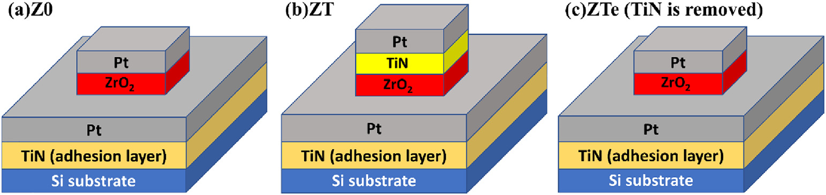

Fig. 1. Schematic illustration of the ZrO2 MIM structures: the (a) Z0, (b) ZT, and (c) ZTe samples, respectively. A TiN capping layer was deposited on the ZrO2 thin film in the ZT and ZTe samples, and then this TiN capping layer was etched away for the ZTe sample.

2

C.-Y. Wang, C.-I. Wang, S.-H. Yi, et al. Materials and Design 195 (2020) 109020

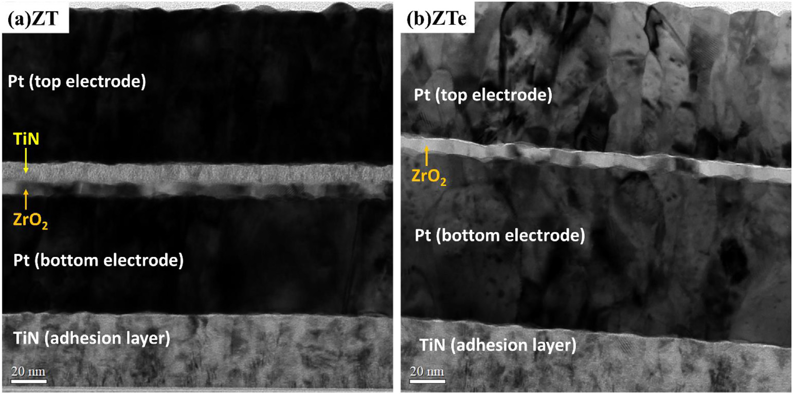

Fig. 2. Cross-sectional TEM images of the (a) ZT and (b) ZTe samples, exhibiting the Pt/TiN/ZrO2/Pt and Pt/ZrO2/Pt MIM structures, respectively.

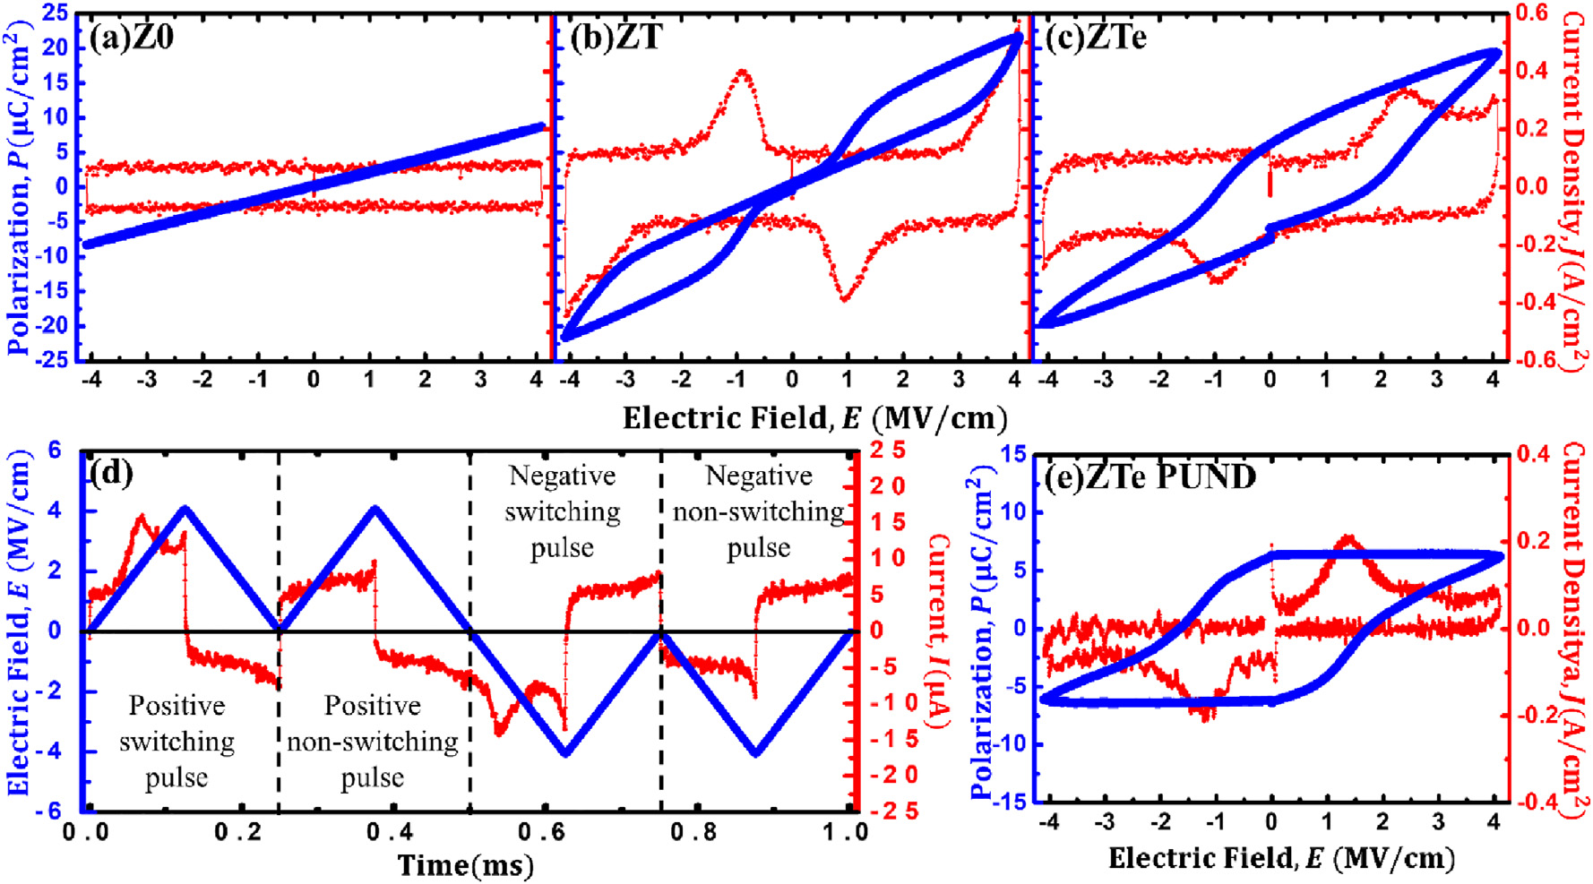

Fig. 3. P-E and J-E curves of the (a) Z0, (b) ZT, and (c) ZTe MIM structures, in which the ZrO2 layer was deposited with a thickness of 7.5 nm at 250 °C. Compared to the Z0 sample, the TiN capping gives rise to the remarkable PE-to-AFE transition in the electrical characteristics of the ZT sample. The electrical properties are converted from being AFE to FE by removing the TiN

capping layer in the ZTe sample. (d) The PUND measurement of the ZTe sample: the triangular electrical-field excitation waveform and the current response at a frequency of 2 kHz. (e) The P-E and J-E curves extracted from the PUND method, revealing the 2Pr ~ 12.7μC/cm2of the ZTe sample.

results in significant transformation from the AFE (Fig. 3(b)) to FE (Fig. 3 (c)) characteristics, suggesting that the crystalline phase is dominated by o-phase in the ZTe sample [27,38–41]. In order to eliminate the con-tribution from the leakage and capacitive non-switching components, the positive-up-negative-down (PUND) method was performed, as shown in Fig. 3 (d), to accurately extract the remanent polarization (Pr) from the FE P-E hysteresis curve. The P-E and J-E curves of the ZTe sample corrected by the PUND method, giving 2Pr of 12.7μC/cm2, are displayed in Fig. 3 (e). The result demonstrates that the TiN capping layer is capable of tailoring the dielectric properties of the PE/AFE/FE phase transition in the as-deposited ZrO2 layer without the need of ad-ditional annealing treatment.

The plots of capacitance (C) and dielectric constant (εr) versus applied voltage (V) of Z0, ZT, and ZTe MIM structures are shown in Fig. 4, where εr of the ZrO2 thin films were extracted from the

3

C.-Y. Wang, C.-I. Wang, S.-H. Yi, et al. Materials and Design 195 (2020) 109020

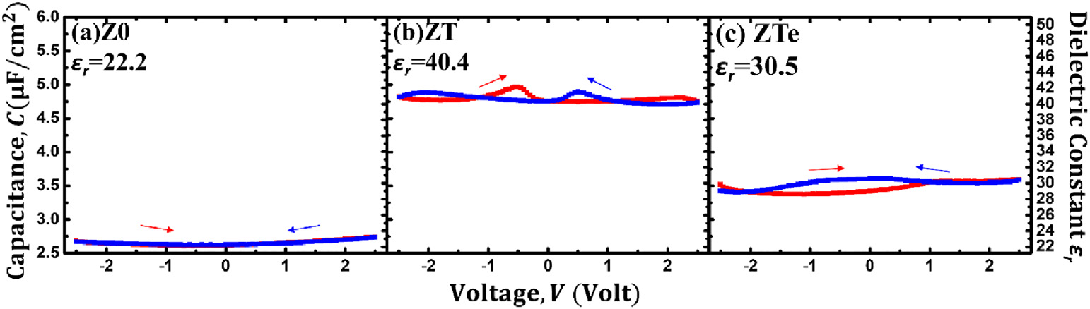

Fig. 4. The capacitance and the dielectric constant εr as a function of the applied voltage of the (a) Z0, (b) ZT, and (c) ZTe MIM structures, in which the ZrO2 layer was deposited with a

thickness of 7.5 nm at 250 °C. The typical AFE (two pairs of butterfly-like peaks) and FE (double peaks) characteristics appear in the C-V curves of the ZT and ZTe samples, respectively.

The diffraction patterns of the Z0, ZT, and ZTe samples probed by the out-of-plane XRD are given in Fig. 5. The Voigt profile, which is the convo-lution of Gaussian and Lorentzian function, was employed to fit the XRD signals for the extraction of the peak positions in 2θ. The International Center of Diffraction Data (ICDD) of the monoclinic (m-) (111) (m(111), 2θ = 28.213°, JCPDS card 89–9066) [44], cubic (c-) (111) (c(111), 2θ = 30.120°, JCPDS card 49–1642) [45], orthorhombic (111) (o(111), 2θ = 30.133°, JCPDS card 79–1796) [46], and tetragonal (101) (t(101), 2θ = 30.223°, JCPDS card 79–1769) [47] ZrO2 phases are shown in the bottom panel of Fig. 5. It can beobserved that a small diffrac-tion peak is present around 2θ ~ 30.35° in the Z0 sample, revealing that the as-deposited ZrO2 thin film is mostly amorphous with slight crystal-linity. The deviation of 2θ ~ 30.35° from those of the standard c(111)/o (111)/t(101) ZrO2 phases manifests the presence of the out-of-plane compressive strain in the thin film. In general, the out-of-plane compres-sive strain is caused by the in-plane tensile stress in the thin film [48], as a result of the surface energy effect [49–51], thermal expansion mismatch [32,52], nuclei coalescence [53], the formation of oxygen vacancies [54], etc. An increase of the XRD intensity and a further shift of the XRD peak to 2θ ~ 30.52° are seen in the ZT sample, clearly indicating the emergence of the amorphous-to-crystalline phase transformation and an increase of the out-of-plane compressive strain caused by capping the TiN layer, as-cribed to the “capping layer effect” [27,53]. A slight backward shift of the XRD peak to 2θ ~ 30.46° in the ZTe sample suggests the relaxation of the out-of-plane compressive strain due to the removal of the TiN

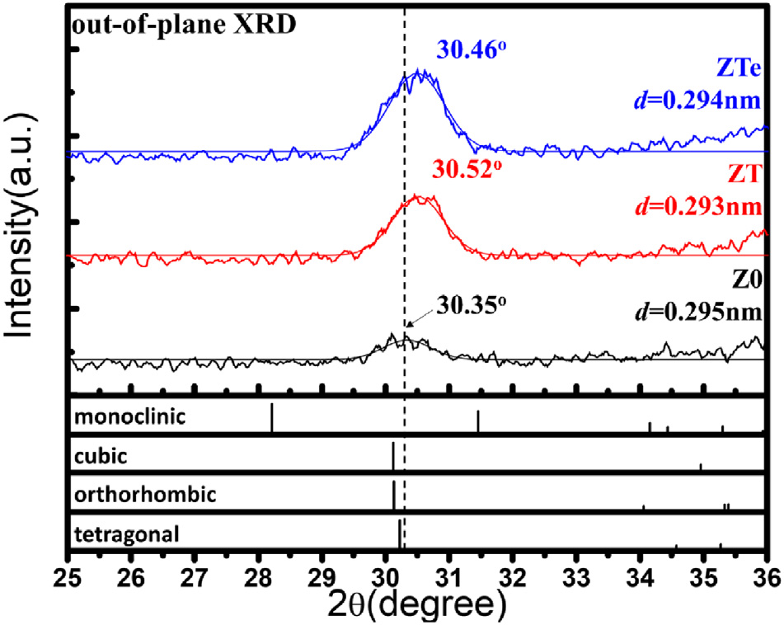

Fig. 5. The out-of-plane XRD patterns of the Z0, ZT, and ZTe samples (the ZrO2 layer was deposited with a thickness of 7.5 nm at 250 °C), in which the XRD signals were fitted by the Voigt function. The Z0 sample exhibits a small XRD peak at 2θ = 30.35°, which is close to the ZrO2 c/t/o-phases. The crystallinity of the ZrO2 layer increases with the deposition of the TiN capping layer in the ZT and ZTe samples. As compared with the Z0 sample, the shift of the XRD peaks of the ZT and ZTe samples toward ~30.5oreveals the emergence of the out-of-plane compressive strain in the ZrO2 thin films.

4

C.-Y. Wang, C.-I. Wang, S.-H. Yi, et al. Materials and Design 195 (2020) 109020

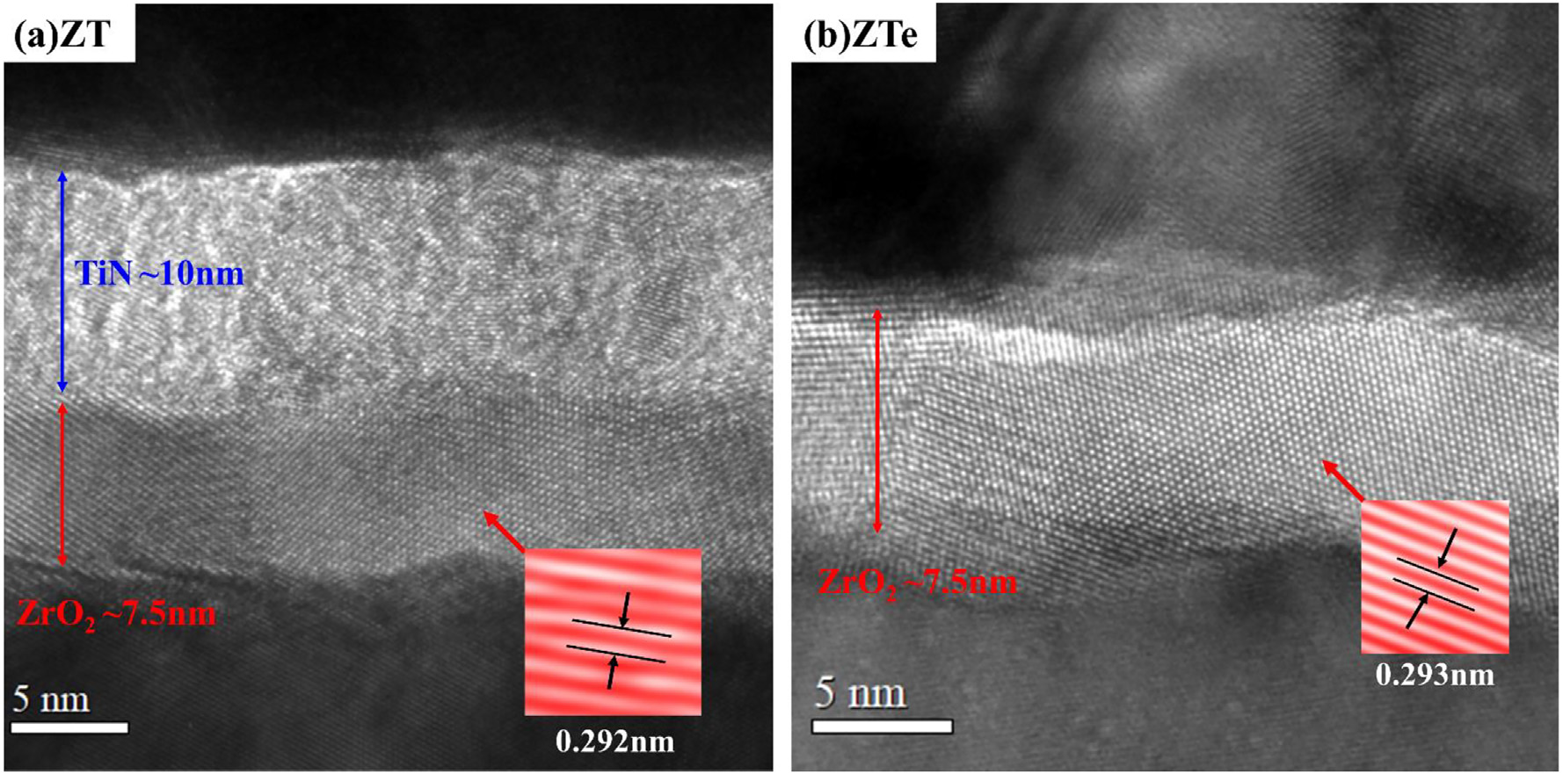

Fig. 6. The HRTEM images of the (a) the ZT and (b) the ZTe MIM structures (the ZrO2 layer was deposited with a thickness of 7.5 nm at 250 °C), in which the ZrO2 and TiN thicknesses are ~7.5, and ~ 10 nm, respectively. The inverse FFT images are shown in the insets, giving the d-spacing of ZrO2 close to the out-of-plane direction are 0.292 nm and 0.293 nm for the ZT and ZTe samples, respectively.

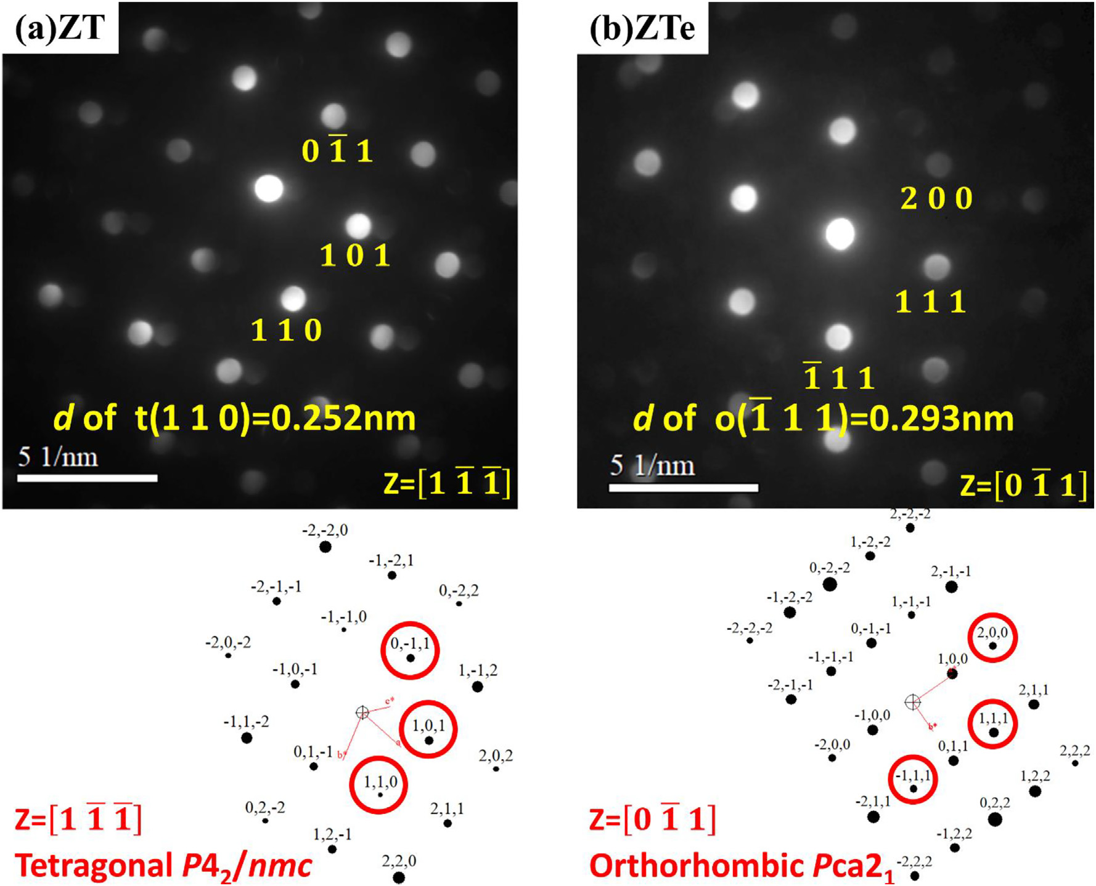

Fig. 7. The NBED patterns of the ZrO2 layer in the (a) ZT and (b) ZTe MIM structures, in which the ZrO2 layer was deposited with a thickness of 7.5 nm at 250 °C. The diffraction patterns in (a) and (b) agree well with the ZrO2 tetragonal P42/nmc and orthorhombic Pca21 space groups, respectively. The d-spacing ~0.252 nm of the t(110) plane near the out-of-plane direction in (a) is lower than that (~0.254 nm) of the standard t(110), revealing the presence of the out-of-plane compressive strain in the ZrO2 thin film. The higher d-spacing ~0.296 nm of o(111)

than that (~0.293 nm) of o(111), as shown in (b), also implies the presence of the out-of-plane compressive and in-plane tensile strains in the ZrO2 layer.

5

C.-Y. Wang, C.-I. Wang, S.-H. Yi, et al. Materials and Design 195 (2020) 109020

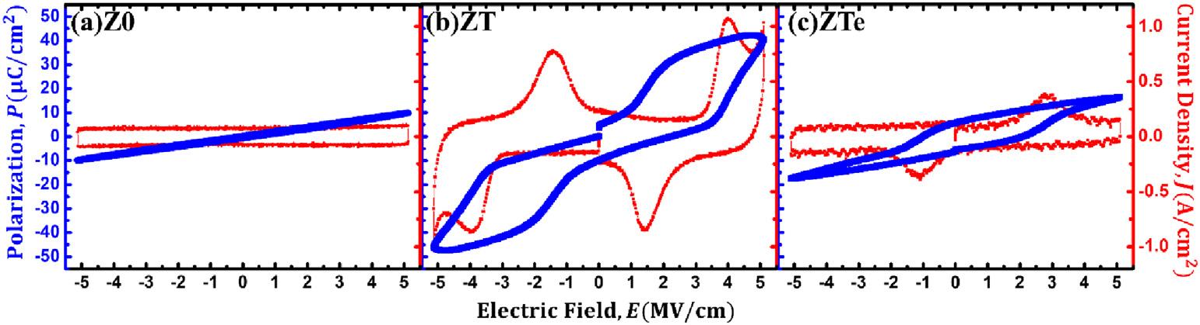

Fig. 8. P-E and J-E curves of the (a) Z0, (b) ZT, and (c) ZTe MIM structures, in which the ZrO2 layer was deposited with a thickness of 6 nm at 200 °C. Similar to those shown in Fig. 3, the TiN capping causes the PE-to-AFE transformation in the electrical characteristics of the ZT sample, and the removal of the TiN capping layer results in the AFE t- to FE o-phase transition in the ZTe sample.

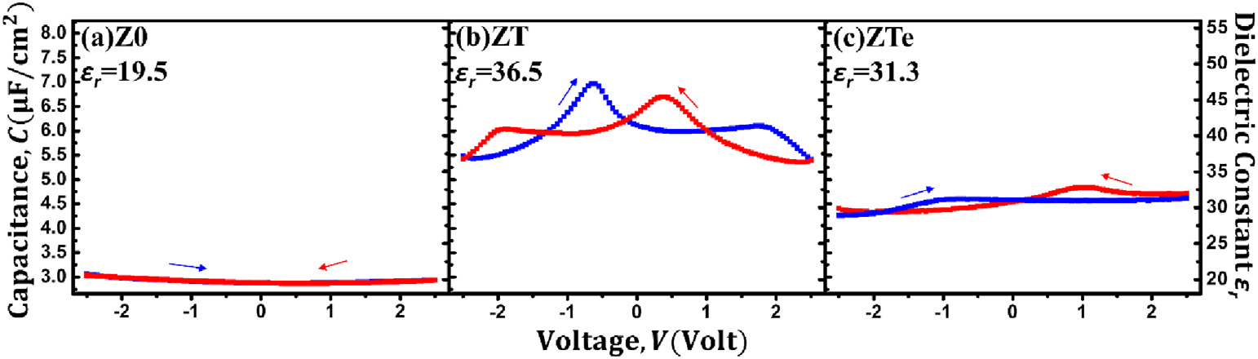

Fig. 9. The capacitance and the dielectric constant εr as a function of the applied voltage of the (a) Z0, (b) ZT, and (c) ZTe MIM structures, in which the ZrO2 layer was deposited with a thickness of 6 nm at 200 °C. The typical AFE (two pairs of butterfly-like peaks) and FE (double peaks) characteristics are present in the C-V curves of the ZT and ZTe samples, respectively, which are similar to those shown in Fig. 4.

in-plane direction, which is higher than that (~0.293 nm) of the o(111) 4. Conclusion

plane along the out-of-plane direction. Since the o(111) and o(111) planes belong to the same family, the higher d-spacing of o(111) than

that of o(111) suggest the out-of-plane compressive and in-plane ten-sile strains in the ZrO2 layer.

One might wonder whether the PE/AFE/FE phase transformation of ZrO2 originates from the annealing effect at 300 °C or the impact of the N2/H2 plasma treatment during the TiN deposition. Hence, the addi-tional experiments were performed to clarify the cause of phase trans-formation. Fig. S1 in Supplementary Material shows the P-E and J-E curves of the Z0 MIM structure, in which the ZrO2 layer was treated at 300 °C in the ALD chamber for the same time as that for the deposition of 10 nm TiN layer. A clear PE feature is seen in the P-E and J-E character-istics. On the other hand, the effect of the N2/H2 plasma treatment on the ZrO2 layer is shown in the P-E and J-E data of the Z0 MIM structure (Fig. S2 in Supplementary Material). The N2/H2 plasma treatment was carried out using the same processing condition as that used for the TiN deposition. No AFE or FE switching currents can be observed in the J-E curves, thus revealing a PE characteristic of the ZrO2 layer after the N2/H2 plasma treatment. As a result, it can be deduced that the PE/ AFE/FE phase transition of ZrO2 cannot be attributed to the post-annealing effect and the N2/H2 plasma treatment on the ZrO2 layer.

Figs. 8 and 9 present the second set of experimental data (P-E, J-E, and C-V curves) of the Z0, ZT, and ZTe MIM structures, in which the ZrO2 layer was deposited with a thickness of 6 nm at 200 °C. It can be observed that obvious PE, AFE, and FE characteristics emerge in the Z0, ZT, and ZTe MIM structures, which are highly consistent with those shown in Figs. 3 and 4. The TiN capping transfers the ZrO2 crystal-line structure from the PE amorphous to the AFE t-phase, and the re-moval of the TiN capping layer results in the AFE t- to FE o-phase transition of ZrO2. Hence, Figs. 8 and 9 also demonstrate the dramatic PE/FE/AFE transformation by the TiN capping engineering on the ZrO2 thin film even prepared with a lower thickness (~6 nm) and at a lower temperature (200 °C).

6

C.-Y. Wang, C.-I. Wang, S.-H. Yi, et al.

Appendix A. Supplementary data

Supplementary data to this article can be found online at [https://doi. org/10.1016/j.matdes.2020.109020](https://doi.org/10.1016/j.matdes.2020.109020).

References

[1] [H. Kohlstedt, et al., Current status and challenges of ferroelectric memory devices,](http://refhub.elsevier.com/S0264-1275(20)30555-4/rf0005)  [Microelectron. Eng. 80 (2005) 296–304](http://refhub.elsevier.com/S0264-1275(20)30555-4/rf0005).

[2] [N. Setter, et al., Ferroelectric thin f](http://refhub.elsevier.com/S0264-1275(20)30555-4/rf0010)i[lms: review of materials, properties, and applica-](http://refhub.elsevier.com/S0264-1275(20)30555-4/rf0010) [tions, J. Appl. Phys. 100 (5) (2006), 051606](http://refhub.elsevier.com/S0264-1275(20)30555-4/rf0010).

[3] [V. Garcia, M. Bibes, Ferroelectric tunnel junctions for information storage and pro-](http://refhub.elsevier.com/S0264-1275(20)30555-4/rf0015) [cessing, Nat. Commun. 5 (1) (2014) 1–12](http://refhub.elsevier.com/S0264-1275(20)30555-4/rf0015).

[4] [T. Francois, et al., Demonstration of BEOL-compatible ferroelectric Hf0.5Zr0.5O2 scaled FeRAM co-integrated with 130nm CMOS for embedded NVM applications, 2019 IEEE International Electron Devices Meeting (IEDM), IEEE, 2019](http://refhub.elsevier.com/S0264-1275(20)30555-4/rf0020).

[5] [T. Ali, et al., High endurance ferroelectric hafnium oxide-based FeFET memory with-](http://refhub.elsevier.com/S0264-1275(20)30555-4/rf0025) [out retention penalty, IEEE Transac. Electron Dev. 65 (9) (2018) 3769–3774](http://refhub.elsevier.com/S0264-1275(20)30555-4/rf0025).

[6] [C. Kittel, Theory of antiferroelectric crystals, Phys. Rev. 82 (5) (1951) 729](http://refhub.elsevier.com/S0264-1275(20)30555-4/rf0030).

[7] [E. Sawaguchi, H. Maniwa, S. Hoshino, Antiferroelectric structure of lead zirconate,](http://refhub.elsevier.com/S0264-1275(20)30555-4/rf0035)  [Phys. Rev. 83 (5) (1951) 1078](http://refhub.elsevier.com/S0264-1275(20)30555-4/rf0035).

[8] [G. Shirane, E. Sawaguchi, Y. Takagi, Dielectric properties of lead zirconate, Phys. Rev.](http://refhub.elsevier.com/S0264-1275(20)30555-4/rf0040)  [84 (3) (1951) 476](http://refhub.elsevier.com/S0264-1275(20)30555-4/rf0040).

[9] [M.H. Park, et al., Toward a multifunctional monolithic device based on pyroelectric-ity and the electrocaloric effect of thin antiferroelectric HfxZr1−xO2 f](http://refhub.elsevier.com/S0264-1275(20)30555-4/rf0045)i[lms, Nano En-ergy 12 (2015) 131–140.](http://refhub.elsevier.com/S0264-1275(20)30555-4/rf0045)

[10] [A. Mischenko, et al., Giant electrocaloric effect in thin-f](http://refhub.elsevier.com/S0264-1275(20)30555-4/rf0050)i[lm PbZr0.95Ti0.05O3, Science](http://refhub.elsevier.com/S0264-1275(20)30555-4/rf0050)  [311 (5765) (2006) 1270–1271.](http://refhub.elsevier.com/S0264-1275(20)30555-4/rf0050)

[11] [W. Geng, et al., Giant negative electrocaloric effect in antiferroelectric La-doped Pb (ZrTi)O3 thin f](http://refhub.elsevier.com/S0264-1275(20)30555-4/rf0055)i[lms near room temperature, Adv. Mater. 27 (20) (2015) 3165–3169](http://refhub.elsevier.com/S0264-1275(20)30555-4/rf0055). [12] [X. Wang](http://refhub.elsevier.com/S0264-1275(20)30555-4/rf0055)[, et al., Energy-storage performance and pyroelectric energy harvesting ef-fect of PNZST antiferroelectric thin f](http://refhub.elsevier.com/S0264-1275(20)30555-4/rf0060)i[lms, J. Mater. Sci. Mater. Electron. 28 (2) (2017) 1438–1448](http://refhub.elsevier.com/S0264-1275(20)30555-4/rf0060).

[13] [B. Lu, et al., Large electrocaloric effect in relaxor ferroelectric and antiferroelectric lanthanum doped lead zirconate titanate ceramics, Sci. Rep. 7 (2017) 45335](http://refhub.elsevier.com/S0264-1275(20)30555-4/rf0065).

[14] [M. Lee, et al., Steep slope and near non-hysteresis of FETs with antiferroelectric-like](http://refhub.elsevier.com/S0264-1275(20)30555-4/rf0070)  [HfZrO for low-power electronics, IEEE Electron Dev. Lett. 36 (4) (2015) 294–296](http://refhub.elsevier.com/S0264-1275(20)30555-4/rf0070). [15] [S. Dasgupta, et al., Sub-kT/qSwitching in strong inversion in PbZr0.52Ti0.48O3 gated neg-](http://refhub.elsevier.com/S0264-1275(20)30555-4/rf0075) [ative capacitance FETs, IEEE J. Exploratory Solid-State Comput. Dev. Circ. 1 (2015)](http://refhub.elsevier.com/S0264-1275(20)30555-4/rf0075)  [43–48](http://refhub.elsevier.com/S0264-1275(20)30555-4/rf0075).

[16] [C. Jin, et al., Experimental study on the role of polarization switching in subthreshold characteristics of HfO 2-based ferroelectric and anti-ferroelectric FET, 2018 IEEE In-ternational Electron Devices Meeting (IEDM), IEEE, 2018](http://refhub.elsevier.com/S0264-1275(20)30555-4/rf0080).

[17] [S. Patel, A. Chauhan, R. Vaish, A technique for giant mechanical energy harvesting using ferroelectric/antiferroelectric materials, J. Appl. Phys. 115 (8) (2014), 084908](http://refhub.elsevier.com/S0264-1275(20)30555-4/rf0085).

[18] [B. Jaffe, Antiferroelectric ceramics with f](http://refhub.elsevier.com/S0264-1275(20)30555-4/rf0090)i[eld-enforced transitions: a new nonlinear](http://refhub.elsevier.com/S0264-1275(20)30555-4/rf0090)  [circuit element, Proc. IRE 49 (8) (1961) 1264–1267](http://refhub.elsevier.com/S0264-1275(20)30555-4/rf0090).

[19] [M. Hoffmann, et al., Ferroelectric phase transitions in nanoscale HfO2 f](http://refhub.elsevier.com/S0264-1275(20)30555-4/rf0095)i[lms enable giant pyroelectric energy conversion and highly eff](http://refhub.elsevier.com/S0264-1275(20)30555-4/rf0095)i[cient supercapacitors, Nano En-ergy 18 (2015) 154–164](http://refhub.elsevier.com/S0264-1275(20)30555-4/rf0095).

[20] [D. Polla, P. Schiller, Integrated ferroelectric microelectromechanical systems](http://refhub.elsevier.com/S0264-1275(20)30555-4/rf0100)  [(MEMS), Integr. Ferroelectr. 7 (1–4) (1995) 359–370](http://refhub.elsevier.com/S0264-1275(20)30555-4/rf0100).

[21] [S. Bharadwaja, S. Krupanidhi, Antiferroelectric thin f](http://refhub.elsevier.com/S0264-1275(20)30555-4/rf0105)i[lms for MEMs applications, Fer-](http://refhub.elsevier.com/S0264-1275(20)30555-4/rf0105) [roelectrics 263 (1) (2001) 39–44](http://refhub.elsevier.com/S0264-1275(20)30555-4/rf0105).

[22] [A.I. Khan, et al., Ferroelectric negative capacitance MOSFET: Capacitance tuning & antiferroelectric operation, 2011 International Electron Devices Meeting, IEEE, 2011](http://refhub.elsevier.com/S0264-1275(20)30555-4/rf0110). [23] [Z. Krivokapic, et al., 14nm ferroelectric FinFET technology with steep subthreshold slope for ultra low power applications, 2017 IEEE International Electron Devices Meeting (IEDM), IEEE, 2017](http://refhub.elsevier.com/S0264-1275(20)30555-4/rf0115).

[24] [L. Zhao, et al., Lead-free antiferroelectric silver niobate tantalate with high energy](http://refhub.elsevier.com/S0264-1275(20)30555-4/rf0120)  [storage performance, Adv. Mater. 29 (31) (2017) 1701824](http://refhub.elsevier.com/S0264-1275(20)30555-4/rf0120).

[25] [B. Hanrahan, et al., Combining inverse and conventional pyroelectricity in antiferroelectric thin f](http://refhub.elsevier.com/S0264-1275(20)30555-4/rf0125)i[lms for energy conversion, J. Mater. Chem. C 6 (36) (2018) 9828–9834](http://refhub.elsevier.com/S0264-1275(20)30555-4/rf0125).

[26] [I. Kanno, Piezoelectric MEMS: ferroelectric thin f](http://refhub.elsevier.com/S0264-1275(20)30555-4/rf0130)i[lms for MEMS applications, Jpn. J.](http://refhub.elsevier.com/S0264-1275(20)30555-4/rf0130)  [Appl. Phys. 57 (4) (2018), 040101](http://refhub.elsevier.com/S0264-1275(20)30555-4/rf0130).

[27] [T. Böscke, et al., Ferroelectricity in hafnium oxide thin f](http://refhub.elsevier.com/S0264-1275(20)30555-4/rf0135)i[lms, Appl. Phys. Lett. 99 (10)](http://refhub.elsevier.com/S0264-1275(20)30555-4/rf0135)  [(2011) 102903](http://refhub.elsevier.com/S0264-1275(20)30555-4/rf0135).

7